

Name_______________________________

**MATHEMATICS SPECIALIST 3 & 4**

**Test 6 2018**

**Calculator-assumed**

Reading Time: 50 minutes

Time Allowed: 3 minutes Total Marks: 50

**Question 1 (4 marks)**

A particle moves in a straight line and, at time $t$, the displacement from a fixed origin is $x$, while $v$ denotes the velocity.

If the particle moves in the region $x<2$, and $v={(x-2)}^{2}$, find the acceleration when $v=4$.

**Question 2 (5 marks)**

An object, initially at rest, is dropped from the top of tall building so that after $t$ seconds it has velocity $v$ meters per second.

The air resistance encountered by the object is proportional to its velocity, so that the velocity satisfies the equation $\frac{dv}{dt}=10-kv$, where $k$ is a constant.

(a) Express the velocity of the object in terms of $t$ and $k$. (4 marks)

(b) Sensors on the object indicate that its velocity will never exceed 55 metres per second. Determine the value of the constant $k$. (1 mark)

**Question 3 (6 marks)**

Kelly and Patsy meet up once a week for coffee. The time ($T$) in minutes that Kelly arrives later than Patsy is uniformly distributed with $-5≤T≤10$. The population mean is $μ\left(T\right)=2.5$ and the population variance is $σ^{2}\left(T\right)=18.75$.

Patsy decides to keep a record of how late (or early) Kelly is over the course of a year (52 meet-ups). She determines the sample mean $(\overline{T})$ for this data.

(a) Determine $P(2≤\overline{T}≤3)$ correct to 2 decimal places. (3 marks)

(b) If a large number of samples, each with 52 meet-ups, is taken, sketch the likely distribution of the sample mean $T$ below.

In the diagram indicate or refer to the calculation from part (a) (3 marks)

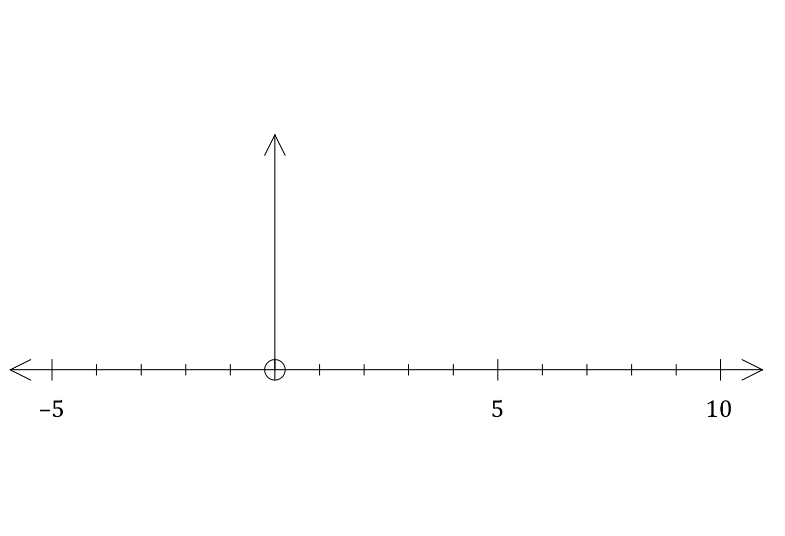

$\overline{T}$ (minutes)

**Question 4 (6 marks)**

(a) The position of a particle is given by $x=e^{-2t}$ where $t$ is measured in minutes.

Find the velocity and the acceleration at $t=1$. (3 marks)

(b) A body moves according to the law $x=-3sin\left(2t+\frac{π}{6}\right)$.

Show the body is moving in SHM. (3 marks)

**Question 5 (7 marks)**

(a) A particle undergoing simple harmonic motion with a period of 5 seconds is observed to move in a straight line, oscillating 3.6 m either side of a central position. Determine the speed of the particle when it is 3 m from the central position. (3 marks)

(b) Another particle moving in a straight line experiences an acceleration of ms-2, where is the position of the particle at time $t$ seconds.

Given that when $x=1$, the particle had a velocity of 2 ms-1, determine the velocity of the particle when $x=2$. (4 marks)

**Question 6 (8 marks)**

A particle moves along a straight line. Its displacement $x$ metres from a fixed point $O$ after $t$ seconds have elapsed is such that

$$\frac{dx}{dt}=\frac{1}{2x-4}$$

If $x=3$ when $t=0$, find

(a) $x$ as a function of $t$ (6 marks)

(b) the distance travelled in the first 24 seconds. (2 marks)

**Question 7 (13 marks)**

A large supermarket chain has decided to change its supplier for its home brand batteries. The batteries need to last for 9000 hours. Barry tests a random sample of 150 batteries from a supplier. The sample mean is found to be 9200 hours and the sample standard deviation 375 hours.

(a) Based on Barry’s sample, obtain a 95% confidence interval for $μ$, the population mean battery life. (4 marks)

(b) State whether each of the following statements is true or false. Provide reasons for your answer and state any assumptions.

(i) If another sample of 150 batteries is taken, then the sample mean will fall within the confidence interval found at part (a). (2 marks)

(ii) If a single battery is selected at random then there is a 95% chance that the battery will have a life that will fall within the confidence interval found at part (a). (2 marks)

Barry’s supervisor, Steve, is a bit concerned. Steve isn’t certain that the life of the batteries are actually normally distributed, and hence the calculation of the confidence interval will not be correct.

(c) What should Barry say in response to Steve’s concerns? (2 marks)

Before making a final decision on whether or not to go with the new supplier, Barry takes another sample, this time of 100 batteries. He finds that the standard deviation is 400 hours. Barry determines that the confidence interval for the population mean battery life is $9280≤μ≤9420$.

(d) Determine the confidence level, to the nearest 0.1%, used to calculate this interval.

(3 marks)